[](http://www.google.com/url?sa=i&rct=j&q=&esrc=s&source=images&cd=&cad=rja&uact=8&ved=0ahUKEwjRlPvFsIfUAhVBeCYKHYyzAqcQjRwIBw&url=http://techmarketingbuffalo.com/guide-instagram-logo/&psig=AFQjCNFBpP2AkjgE1eprEEsKXajUI-rdrQ&ust=1495675485827712)

**staff**

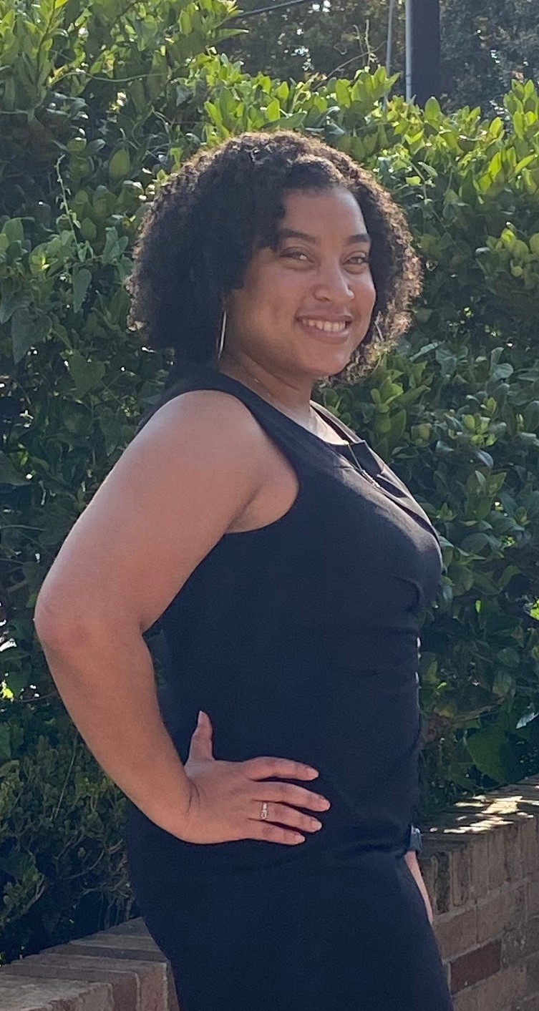

**TEACHER**

[](https://en.wikipedia.org/wiki/Instagram)

Ashley Alexander

**Personal**

**Birthday:** August 31st

**Hometown:** Houston

**Family: I’m an ONLY child. ☺**

**A few of your favorites:** Seafood, Traveling, Grey’s Anatomy, The Good Doctor

**Favorite Hobbies:** Reading, Puzzles, Learning Piano, Running

**Favorite Artist/Music Genre:** Beyonce/ Drake/ Neo-Soul/ Maze & Frankie Beverly/ Earth, Wind & Fire

Pre-AP Chemistry - ECHS

1st year of teaching

Marshall/FBISD: Year 1



Motivational quote/Motto:

Clear is kind. Unclear is unkind. -Brene Brown

**TEACHER**